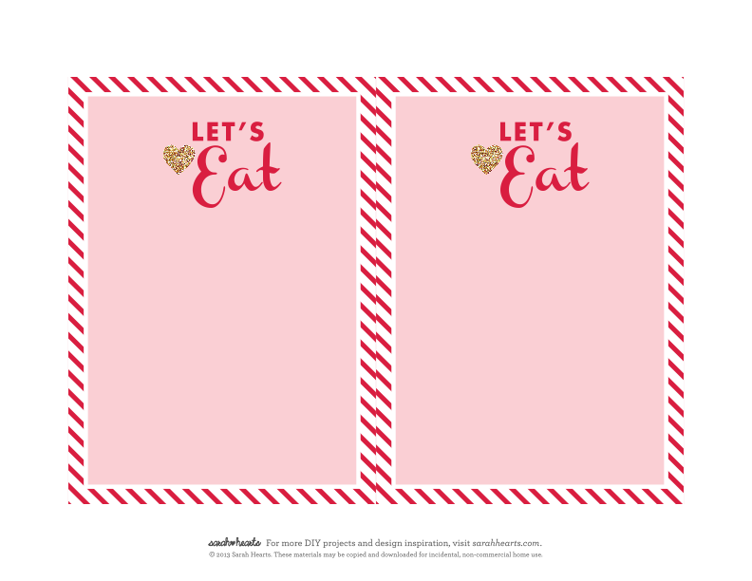
Salad

Main Dish

Side Dish

Side Dish

Dessert

Salad

Main Dish

Side Dish

Side Dish

Dessert

